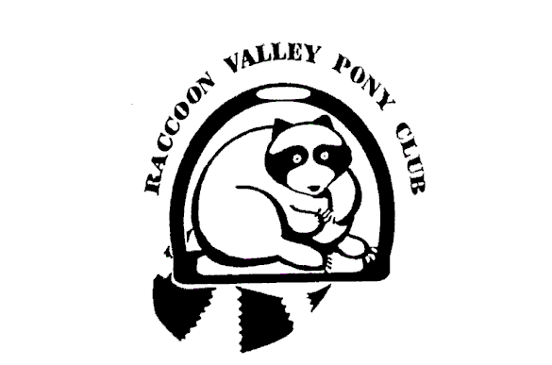

2022 RVPC Membership & Sponsor Application
Renewing Members can complete the USPC National application online. New + Renewing Members should submit this form to the Club.

Date of Application_____________________________

Last Name__________________________ First Name___________________________________

Male ____ Female____ Date of Birth__________________ Current Rating__________________

Address____________________ ______________________________________________

City__________________________________________ Zip Code___________________________

Phone #___________ ___ Member's e-mail address__________________________ _____

Member’s cell phone # ________________________________________________________

Spouse name ____________________________________________________________________

Parent/Guardian name(s) ____________________________________________________________

Work Phone _______________________ e-mail address __________________________________
Cell Phone _______________________________________________________________________

Work Phone _______________________ e-mail address__________________________________
Cell Phone _____________ ____________________________

Please check all that are applicable. These fees include National, Regional and local club fees
Will renew National online. $45 (pay Region $25; Club $20 by check made out to RVPC)
New Member @ $200.00 starting Jan 1 (National $155; Region $25; Club $20)
Pro-rated New Member joining after September 1 for the rest of 2021 and all of 2022 @ $245.00 (National $200; Region $25; Club $20)
Renewing Member @ $190.00 (National $145; Region $25; Club $20)
Late Renewing Member @ $210.00 (Paid after December 31, 2021) (National $145;
Region $40; Club $25)
Name of Sponsor @ $10.00 per sponsor ____________________________________
Name of Sponsor @ $10.00 per sponsor _____________ _______________________

Make Checks payable to RVPC and mail or give these forms and checks to:
Pat Foley, 55789 Oak Bend Rd, Huxley, IA 50124

Thank you!

